# Springboot +easypoi模板导出Excel

官方文档

[http://easypoi.mydoc.io/#category\_49972](http://easypoi.mydoc.io/" \l "category_49972)

2019-05-07 10:39:10 [小码蚁啊](https://me.csdn.net/qq_36802726" \t "https://blog.csdn.net/qq_36802726/article/details/_blank) 阅读数 335更多

分类专栏： [Java](https://blog.csdn.net/qq_36802726/article/category/7421200" \t "https://blog.csdn.net/qq_36802726/article/details/_blank)

版权声明：本文为博主原创文章，遵循[CC 4.0 BY-SA](http://creativecommons.org/licenses/by-sa/4.0/" \t "https://blog.csdn.net/qq_36802726/article/details/_blank)版权协议，转载请附上原文出处链接和本声明。

本文链接：<https://blog.csdn.net/qq_36802726/article/details/89915975>

依赖:

<!-- easypoi简单导出所需要的jar包 start -->

<dependency>

<groupId>cn.afterturn</groupId>

<artifactId>easypoi-base</artifactId>

<version>3.1.0</version>

</dependency>

<dependency>

<groupId>cn.afterturn</groupId>

<artifactId>easypoi-annotation</artifactId>

<version>3.1.0</version>

</dependency>

<dependency>

<groupId>cn.afterturn</groupId>

<artifactId>easypoi-web</artifactId>

<version>3.1.0</version>

</dependency>

<!-- easypoi简单导出所需要的jar包 end-->

excel:

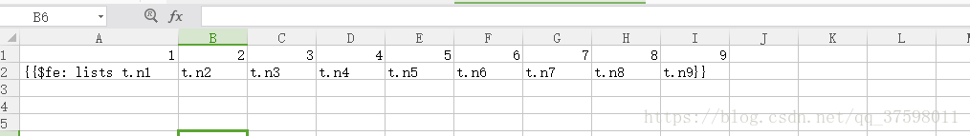

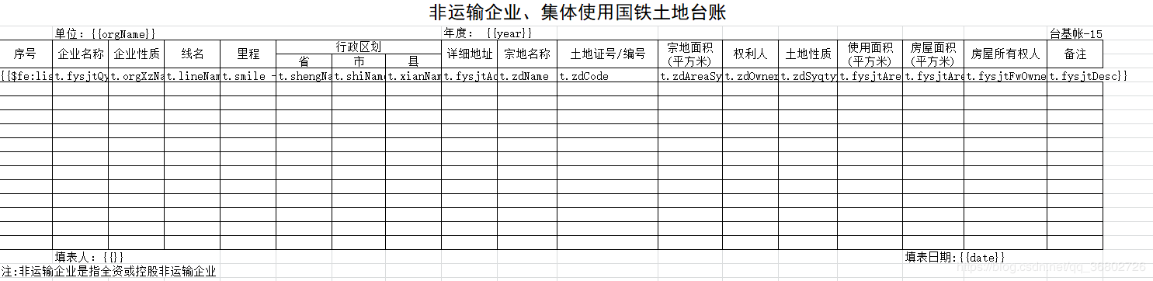

将表格放入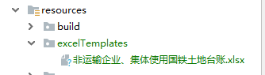

前端用什么框架什么框架都可以Controller主要接收两个参数response和前端传过来的参数params

Controller:

@GetMapping("export")

@ApiOperation("导出")

@LogOperation("导出")

@RequiresPermissions("fysjtsygt:fysjtsygt:export")

public void export(@ApiIgnore @RequestParam Map<String, Object> params, HttpServletResponse response) throws Exception {

List<FysjtsygtDTO> list = fysjtsygtService.list(params);

String fileNmae = "土地台账";

String date = DateUtils.format(new Date());

String year = params.get("ydYear").toString();

String orgName = params.get("orgName").toString();

TemplateExportParams param = new TemplateExportParams("/excelTemplates/土地台账.xlsx", true);

*// 标题开始行*

*// param.setHeadingStartRow(0);*

*// 标题行数*

*// param.setHeadingRows(2);*

*// 设置sheetName，若不设置该参数，则使用得原本得sheet名称*

*//param.setSheetName("班级信息");*

Map<String, Object> data = new HashMap<String, Object>();

data.put("date", date);*//导出一般都要日期*

data.put("year", year);*//导出一个对象*

data.put("orgName", orgName);*//导出一个对象*

data.put("list", list);*//导出list集合*

try {

Workbook book = ExcelExportUtil.exportExcel(param, data);

*//下载方法*

export(response, book, fileNmae);

} catch (Exception e) {

System.out.println("导出模板Excel，失败:" + e);

}

}

*/\*\**

*\* export导出请求头设置*

*\**

*\* @param response*

*\* @param workbook*

*\* @param fileName*

*\* @throws Exception*

*\*/*

private static void export(HttpServletResponse response, Workbook workbook, String fileName) throws Exception {

response.reset();

response.setContentType("application/x-msdownload");

response.setHeader("Content-disposition", "attachment; filename=" + java.net.URLEncoder.encode(fileName+".xlsx", "UTF-8"));

ServletOutputStream outStream = null;

try {

outStream = response.getOutputStream();

workbook.write(outStream);

} finally {

outStream.close();

}

}

异常 ： firstMovedIndex,lastMovedIndex out of order

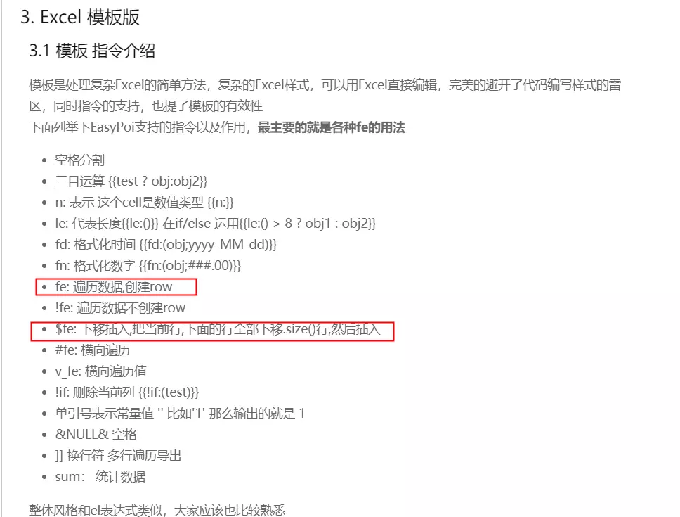

我的模板里用的是"$fe"来进行遍历插入的，但是我需要遍历插入的数据下发是没有其他数据的，这就导致其执行时，要将下方语句下移时，发生了越界。改用“fe”完美解决了问题。

下面附一个适合用“$fe”的模板：

